2015-16 Community Report for Colby Village Elementary School
At Colby Village, we are in year three of our SSP (Student Support Plan). Year three schools continue to examine the progress of students to date and determine where strengths lie and where students are still experiencing challenges.

Supporting these challenges could involve changing teaching practices to accommodate the needs of specific learners, as well as providing extra support for students, either through one-on-one instruction or by small group teaching during mini-lessons.

Student progress is a continuous discussion among staff (either during PLC meetings, PD or informally) to ensure students are achieving at their full potential.

As a reminder, the two goals we developed two years ago were:

1. Students will improve in reading comprehension with a focus on critical responses to text.

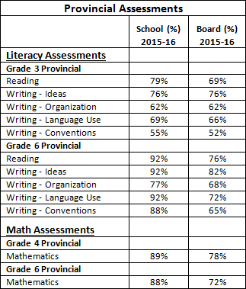
2. Students will improve their ability to problem solve and communicate their mathematical thinking.

Both of these goals are interrelated as they require teachers in supporting students to dig deeper; to be able to develop skills that will help them go beneath the surface and become more tenacious learners.

Last year, our professional development focused on the understanding, assessing and teaching of comprehension: what it is, how it’s achieved and how it’s measured were analyzed in PD sessions and PLCs. Use of resources by experts such as Harvey Daniels led us to discussions around the difference between getting meaning and making meaning. Clearly for us, the best way to address these concerns was through an effective and meaningful reading and writing workshop model. During our initial PLC meetings for this year, it was determined that some of the ways we collected data on reading comprehension needed to be adjusted, to give us the best possible information to impact our classroom instruction. It became clear that we needed to look at various levels of development within comprehension. At the younger grades there are aspects of comprehension that are difficult to assess because the level of text doesn’t lend itself to more in depth comprehension questions. For that reason, we have shifted assessments in grades P-1 to focusing on simple connections to text. Grade two will focus on visualization and the grades three to six will focus on comprehension, fluency, connections to text and the ability to infer.

Our PD this year also included workshops on culturally relevant teaching practices to ensure we support all our students in ways that are meaningful to them. As you will see by our external assessment results, students at Colby Village perform well and often at significantly higher than our board average. As a staff, we couldn’t be more proud of our students’ achievements.

We will also continue to keep our school community involved, sharing information with our School Advisory Council and our PTO. Students benefit from as much support as possible. Hearing from and listening to our school community can only help to strengthen the circle of support we offer to our students.

